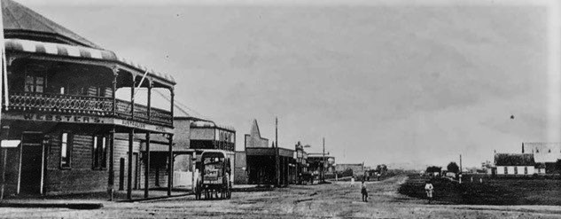
BALLINA & DISTRICT HISTORICAL SOCIETY
President: Brian Mullens 0416 187 429
Exec Secretary: Ann Mulder 0427 291 772
ballinahistoricalsociety@outlook.com
ICN 1900971

APPLICATION FOR MEMBERSHIP FORM
 | First name:
 | Surname:
 | Number & Street:
 | Town/Suburb:
 | State: |  | Postcode:
 | Phone/Mobile: |  | Year of Birth (for insurance purposes):
 | Email:
Membership of the Ballina & District Historical Society costs:
- One-off joining fee of $10 per person plus an annual fee of $20 per person
Membership is for the financial year July to June. Membership is due on or before 1st July.
If NEW membership is taken out after 1st January then the fee will be $10 PLUS $10 joining fee for the 6 months Jan 1st- June 30th
You can make your payment electronically using the account details below, pay at our monthly meetings or go to any St George Bank branch to deposit the fee.
Account details:
Ballina and District Historical Society
BSB: 112879
Account number: 478716649
Reference: Your Name
Privacy/Sharing: I the undersigned understand that my membership details will be kept confidential and will only be accessed by the executive committee for the purpose of contacting you regarding membership fees or other important information as determined by the executive committee.

Signature: ___________________________________________Date: _____________________________________

